Snapshot Schedule

Following the somewhat traditional backup retention model, we'll plan to keep:
- Daily Snapshots for 7 days
- Mark a Snapshot taken every Monday to be kept for 30 days, inherently making that the 'weekly' backup.
- Mark 'weekly' snapshots taken during the first week of the month as 'monthly' and continue to retain just those snapshots for 90 days (quarterly). This way, we don't end up with every weekly snapshot being converted to a 90 day retention.

Setting up the IAM Role
We'll need to create an IAM Role with an attached policy that will allow our Lambdas to interact with the EC2 instances the EBS volumes. (Elastic Block Storage). To do so, load up the AWS management console, browse to IAM > click Roles.
We'll create the role of type Lambda. For now, continue without assigning permissions/policies. I named my role Lambda-Snapshots-EC2 as seen below.

Once the role has been created, return to the Roles screen and select our new role. Click "add inline policy" on the bottom right of your screen. Click the JSON tab, and copy and paste the following:
{
"Version": "2012-10-17",
"Statement": [
{
"Effect": "Allow",
"Action": [
"logs:*"
],
"Resource": "arn:aws:logs:*:*:*"
},
{
"Effect": "Allow",
"Action": "ec2:Describe*",
"Resource": "*"
},
{
"Effect": "Allow",
"Action": [
"ec2:CreateSnapshot",
"ec2:DeleteSnapshot",
"ec2:CreateTags",
"ec2:ModifySnapshotAttribute",
"ec2:ResetSnapshotAttribute"
],
"Resource": [
"*"
]
}
]
}
Essentially, we're saying 3 things here. The first is that we're allowing the CloudWatch logs actions (all of the available CloudWatch log actions can be found here) to be invoked by any resource within the CloudWatch "bucket" resources. "Resource": "arn:aws:logs:*:*:*".
The second declaration is the allowance of any resource (AWS service, object, user, Lambda, basically anything with an arn: ...) leveraged by this policy to perform the any of the EC2 Describe actions. -> ec2:Describe*. This link shows the full list of EC2 actions available. Around 40 of those are probably description based actions.
Our third declaration allows for any AWS resource using this policy to created and delete snapshots, create Tags on the EC2 related resources, and modify/change Snapshot attributes (things like the name of the snapshot, and their individual tags).
"Action": [
"ec2:CreateSnapshot",
"ec2:DeleteSnapshot",
"ec2:CreateTags",
"ec2:ModifySnapshotAttribute",
"ec2:ResetSnapshotAttribute"
],
Once you've got all of that JSON copied into the inline policy editor, advance through the dialogues, naming your policy something logical. We've now got an IAM policythat allows various resources to execute certain actions, attached to an IAM role that allows this policy to be referenced by our forthcoming Lambdas.
Side Note --> If you download the json file from the repo (link at bottom of page), you can use this AWS article to quickly create the needed roles/policies using the AWS CLI, which can be WAY FASTER! https://docs.aws.amazon.com/cli/latest/reference/iam/create-policy.html
Now that we've gotten the roles and resource permissions squared away, we're ready to do the fun stuff.

Creating the Lambda functions
We'll first create the lambda functions within the AWS management console. We'll also create and schedule the triggers, CloudWatch Scheduled Events, using a Cron expression.
We'll have 3 lambda functions (could be condensed to 1), that will run as follows:
- createSnapshot
- handleSnapshot
- deleteSnapshot
For now, we'll just create the functions and apply the scheduling, leaving the actual coding for a bit later on.
Head on over to the Lambda dashboard. Select create function, and then leave author from scratchmarked. I've named this function createSnapshot and we'll set its runtime to Python 2.7
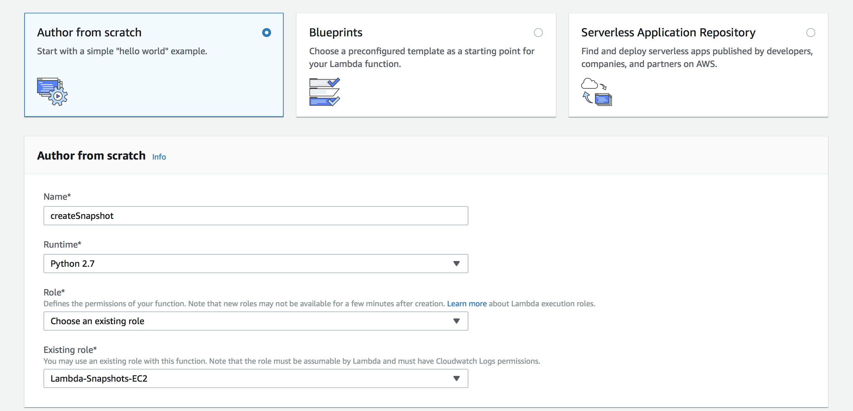
There are quite a bit of windows and options that come up. Amazon has changed the way this page looks several times over the last few years and it can be a bit tricky to navigate. For now, let's focus in on the uppermost section.
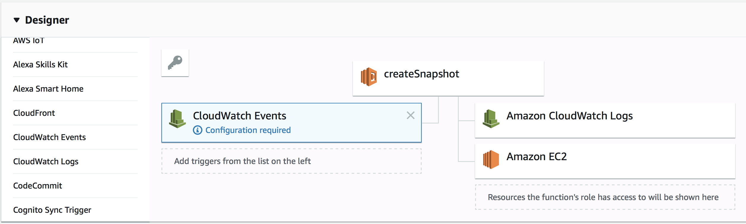
On the left, under Designer, we can scroll through all of the various AWS services that we can have trigger our Lambda. I simply clicked on CloudWatch Events and it was added to the diagram. We can see here that anything on the left under our Lambda (createSnapshot) will trigger the Lambda itself, which will result in outcomes shown on the right. These outcomes were predefined by the actions that we allowed in our IAM Role that we created and then applied when creating this Lambda.
We need to add an actual scheduled event now, which we can do by clicking the Configuration required text. On the dropdown, select Create a New Rule. I've chosen to use a cron expression for scheduling. Please note, this times are in UTC by default, so make sure to accommodate appropriately!
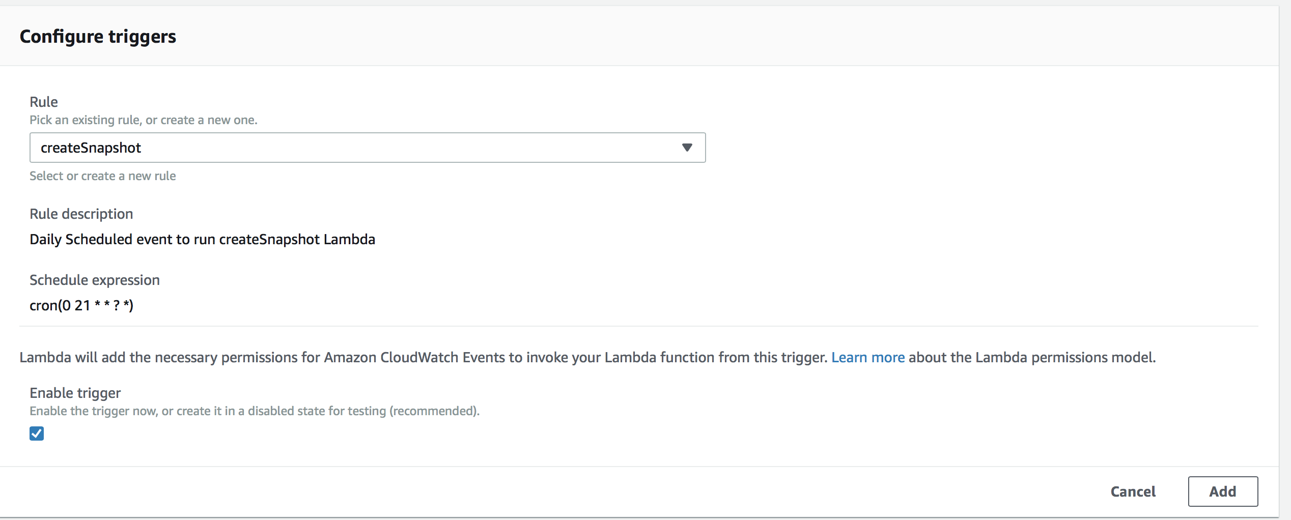
For more info on how Cron Expressions are written, check this out.
So now that we've gotten our fist Lambda function created and scheduled. We'll do the same for the two remaining ones, handleSnapshot and deleteSnapshot.
For handleSnapshot, I'll be using cron(0 22 * * ? *) for scheduling. Similarly, for deleteSnapshot, I'll use cron(0 23 * * ? *).
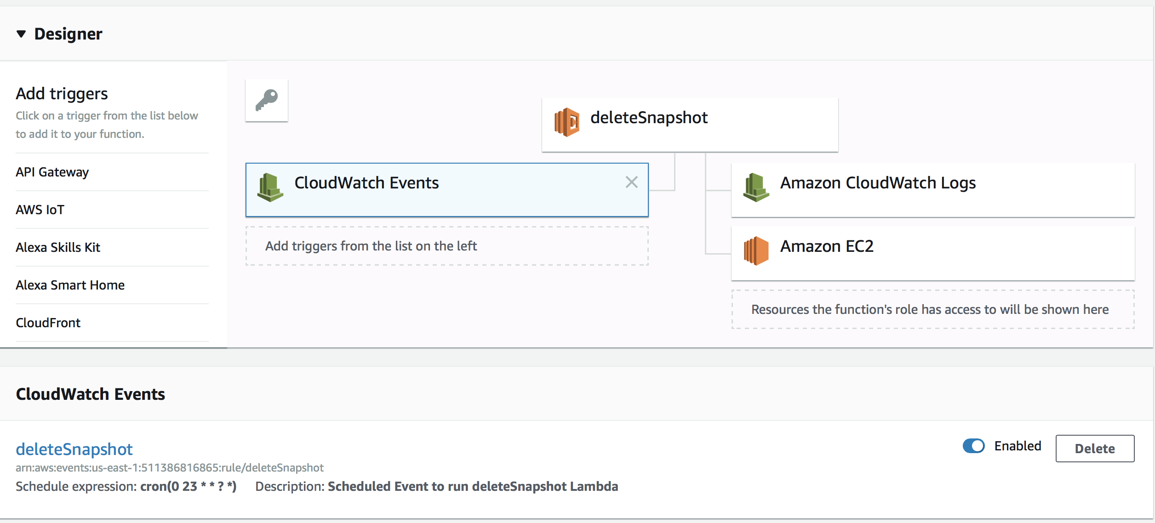
Once we've gotten that locked in, let's meet back here to get some coding in.

Writing the createSnapshot function
Within the createSnapshot Lambda, copy and paste the following code. We'll dissect a little bit more below.
import boto3
import collections
import datetime

#Please mention your region name
#below line code is call cross region
ec = boto3.client('ec2', region_name='us-east-1')

#begins lambda function
def lambda_handler(event, context):
# mention your tag values below example "Backup-snap"
reservations = ec.describe_instances(
Filters=[
{'Name': 'tag-key', 'Values': ['Backup', 'True']},
]
).get(
'Reservations', []
)

instances = sum(
[
[i for i in r['Instances']]
for r in reservations
], [])

print "Number of the Instances : %d" % len(instances)

to_tag = collections.defaultdict(list)

for instance in instances:
try:
retention_days = [
int(t.get('Value')) for t in instance['Tags']
if t['Key'] == 'Retention'][0]
except IndexError:
# Please give your retention period day
retention_days = 7

for dev in instance['BlockDeviceMappings']:
if dev.get('Ebs', None) is None:
continue
vol_id = dev['Ebs']['VolumeId']
for name in instance['Tags']:
# To store the instance tag value
Instancename= name['Value']
# To store the instance key value
key= name['Key']
# Below the code is create Snapshot name as instance Name
if key == 'Name' :
ins_name = Instancename
print "Found EBS volume %s on instance %s" % (
vol_id, instance['InstanceId'])

#To get all the instance tags deatils
for name in instance['Tags']:
# To store the instance tag value
Instancename= name['Value']
# To store the instance key value
key= name['Key']
# actually creates the snapshot and names it the same as instance Name
if key == 'Name' :
snap = ec.create_snapshot(
VolumeId=vol_id,
Description=Instancename,
)
print "snap %s" %snap

to_tag[retention_days].append(snap['SnapshotId'])

print "Retaining snapshot %s of volume %s from instance %s for %d days" % (
snap['SnapshotId'],
vol_id,
instance['InstanceId'],
retention_days,

)
for retention_days in to_tag.keys():
# if this runs on a Monday, then start doing weekly, monthly, or whatever....
if datetime.datetime.today().weekday() == 0:
# set retention to 4 weeks, and tag as Version: Weekly
delete_date = datetime.date.today() + datetime.timedelta(days=30)
print "Snapshot being marked as weekly. Will keep until %s" % str(delete_date)
version = 'Weekly'
else:
version = 'Daily'
delete_date = datetime.date.today() + datetime.timedelta(days=retention_days)

snap = snap['Description'] + str('_')
# Here to get current date
snapshot = snap + str(datetime.date.today())
# to mention the current date formet
delete_fmt = delete_date.strftime('%Y-%m-%d')
print "Will delete %d snapshots on %s" % (len(to_tag[retention_days]), delete_fmt)
# below code is create the name and current date as instance name
ec.create_tags(
# this grabs the snapshot id from the list and applies the following tags
Resources=to_tag[retention_days],
Tags=[
{'Key': 'DeleteOn', 'Value': delete_fmt},
{'Key': 'Name', 'Value': snapshot },
{'Key': 'Version', 'Value': version},
])
to_tag.clear()
The first thing we'll do is import our needed libraries, and set up our ec2 client in our code. A good thing to point out here is the region_name='us-east-1' assignment. Just make sure to match this to the region that your EC2s are running in.
import boto3
import collections
import datetime

#Please mention your region name
#below line code is call cross region
ec = boto3.client('ec2', region_name='us-east-1')
The next line in our function is absolutely critical! It defines an entry point in our code so that the Lambda knows where/how to invoke the file. Similar to the main function in C/Go. def lambda_handler(event, context): ......
The next thing that we're doing is calling the ec:DescribeInstances action via
reservations = ec.describe_instances(
Filters=[
{'Name': 'tag-key', 'Values': ['Backup', 'True']},
]
)
Here we're sorting through our instances in the region that we specified. We'll only select and return the instances that have a a Tag/Value pair of: Backup, True. So our lambda will only grab the instance named 'Do Snapshot!'
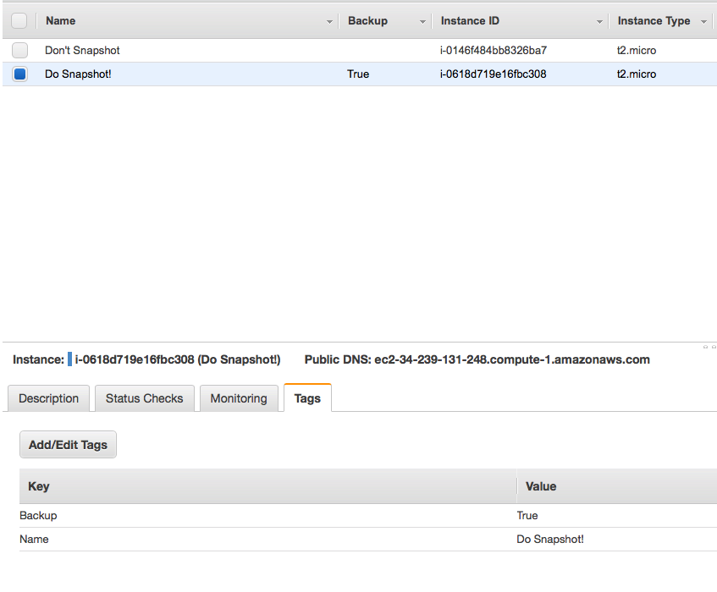
Now we'll push those instance descriptions into a Reservations list.
Next will iterate through our reservations list and tally up the total number or snapshots that we'll be taking, and indexing them in our list accordingly.
Then we'll loop through our instance tags, and reset any tags that may have to do with Retention, in case they're already there. If not, then we'll assign retention_days to 7.
try:
retention_days = [
int(t.get('Value')) for t in instance['Tags']
if t['Key'] == 'Retention'][0]
except IndexError:
# Please give your retention period day
retention_days = 7
Now that the prep work is done, let's actually reach out and get the EBS volumes that we care about. We'll look through our instance description list, in our 'BlockDeviceMappings' sub/embedded list. We'll grab the instance names tied to our volumes, and the volume id, so that we can properly reference it later.
for dev in instance['BlockDeviceMappings']:
if dev.get('Ebs', None) is None:
continue
vol_id = dev['Ebs']['VolumeId']
for name in instance['Tags']:
# To store the instance tag value
Instancename= name['Value']
# To store the instance key value
key= name['Key']
# Below the code is create Snapshot name as instance Name
if key == 'Name' :
ins_name = Instancename
print "Found EBS volume %s on instance %s" % (
vol_id, instance['InstanceId'])

Create the handleSnapshot function
Copy and paste the following code into our handleSnapshot Lambda. As we did above, we'll review some it more below.
import boto3
import re
import datetime

#Please mention your region name
#below line code is call cross region
ec = boto3.client('ec2', region_name='us-east-1')
iam = boto3.client('iam')

#begins lambda function
def lambda_handler(event, context):
account_ids = list()
try:
iam.get_user()
except Exception as e:
# use the exception message to get the account ID the function executes under
account_ids.append(re.search(r'(arn:aws:sts::)([0-9]+)', str(e)).groups()[1])

versions = ["Daily", "Weekly", "Monthly", "Quarterly"]

for version in versions:
delete_on = datetime.date.today().strftime('%Y-%m-%d')
filters = [
{'Name': 'tag-key', 'Values': ['DeleteOn']},
{'Name': 'tag-value', 'Values': [delete_on]},
{'Name': 'tag-key', 'Values': ['Version']},
{'Name': 'tag-value', 'Values': [version]},
]
# get snapshots that match filters
snapshot_response = ec.describe_snapshots(OwnerIds=account_ids, Filters=filters)
# loop through response dict, grabbing snapshots list
for snap in snapshot_response['Snapshots']:
for tag in snap['Tags']:
if tag['Key'] == 'Version':
versionTag = tag['Value']
# filter for weekly tag on snap object
# and only process if within first week of the monthy
if versionTag == 'Weekly' and datetime.datetime.today().day <= 7:
# get 30 days from time of creation
createdDate = (snap['StartTime']).date()
monthlyDate = (createdDate + datetime.timedelta(days=30))
# if date function executes is 1 month from snapshot's creation
if monthlyDate == datetime.date.today():
#set new delete date, 3 months out
new_delete_date = (datetime.date.today() + datetime.timedelta(days=90))
new_delete_date = new_delete_date.strftime('%Y-%m-%d')
# update version and delete on tags to monthly, with a date 3 months out
ec.create_tags(Resources=[snap['SnapshotId']],
Tags=[{
'Key': 'Version',
'Value': 'Monthly'
}, {
'Key': 'DeleteOn',
'Value': new_delete_date
}])
elif versionTag == 'Monthly':
# get 90 days from time of creation to convert to quarterly
createdDate = (snap['StartTime']).date()
quarterlyDate = (createdDate + datetime.timedelta(days=90))
if quarterlyDate == datetime.date.today():
# set new delete date, 6 months out
new_delete_date = (datetime.date.today() + datetime.timedelta(days=180))
new_delete_date = new_delete_date.strftime('%Y-%m-%d')
# update version tag to quarterly and deletion date to 6 m/180 days
ec.create_tags(Resources=[snap['SnapshotId']],
Tags=[{
'Key': 'Version',
'Value': 'Quarterly'
}, {
'Key': 'DeleteOn',
'Value': new_delete_date
}])
elif versionTag == 'Quarterly ':
print "Snapshot, %s marked for final deletion..." %snap['SnapshotId']
else:
print "Snapshot, %s marked for final deletion..." %snap['SnapshotId']
More explanation to come..

Create the deleteSnapshot function
We've now moved onto our last function. We'll check for snapshots that have a DeleteOn date that matches today's date. If it matches and it's no longer going to be edited by our handler, then it'll will ultimately be deleted.
import boto3
import re
import datetime

#Please mention your region name
#below line code is call cross region
ec = boto3.client('ec2', region_name='us-east-1')
iam = boto3.client('iam')

#begins lambda function
def lambda_handler(event, context):
account_ids = list()
try:
iam.get_user()
except Exception as e:
# use the exception message to get the account ID the function executes under
account_ids.append(re.search(r'(arn:aws:sts::)([0-9]+)', str(e)).groups()[1])

# loop through each of the versions and run deletions
# matching delete day + version tag
versions = ['Daily', 'Weekly', 'Monthly', 'Quarterly']
for version in versions:
delete_on = datetime.date.today().strftime('%Y-%m-%d')
filters = [
{'Name': 'tag-key', 'Values': ['DeleteOn']},
{'Name': 'tag-value', 'Values': [delete_on]},
{'Name': 'tag-key', 'Values': ['Version']},
{'Name': 'tag-value', 'Values': [version]}
]
snapshot_response = ec.describe_snapshots(OwnerIds=account_ids, Filters=filters)
for snap in snapshot_response['Snapshots']:
print "Deleting snapshot %s" % snap['SnapshotId']
ec.delete_snapshot(SnapshotId=snap['SnapshotId'])
More explanation to come..

Conclusion
So we've now created our IAM Role/policy to execute our Lambdas, set up our 3 Lambda functions, and scheduled them via CloudWatch Events. Good work! Hopefully this was helpful. As always, let me know if I didn't explain anything properly!

